How to do SNMP WALK With the GUi Tool

Please follow below instructions to check whether the SNMP of target devices (Please choose 1-2 problematic devices as target devices) are working properly.

1. Open the NetBrain SNMPWalkTool.exe (Please download it from: <https://ws2.netbraintech.com/download/SNMPWalkTool.zip>) on your NetBrain Proxy Server (7.0) / NetBrain Front Server (7.1, 8.0), set Target IP address (One device at a time), SNMP credentials to retrieve the SNMP data. Please note that this could take some time. After the process is finished, the program will create a text file of the walk result. Please change the timeout to 60 seconds in the SNMPWalk Options.

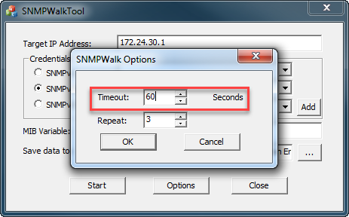

1. Please enter the SNMP string and MIB variable: 1.3.6.1, and start the walk process. (It may take several minutes to retrieve the results).

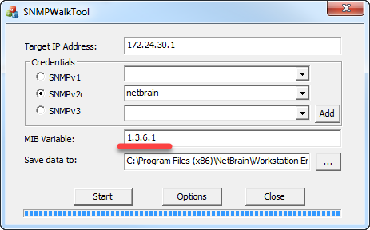

1. Please check the result, if the result is empty(Only contains one line: “Walk OID is 1.3.6.1”), that means the server cannot get SNMP information from the devices.
2. If the result is not empty, please send the saved data as a txt file to us for further analyze.